OBJECT ORIENTED PROGRAMMING

[CT-260]



NAME: ABDUL RAHEEM SHEIKH

ROLL NO: CT-25192

DEPARTMENT: BCIT

BATCH: 2025

YEAR & SECTION: FSCS-D

LAB: 7

CODES
QUESTION 01

#include <iostream>
using namespace std;

class Matrix {
private:
int rows, cols;
int **arr;

public:
// Default Constructor
Matrix() {
rows = cols = 0;
arr = nullptr;
}

// Parameterized Constructor
Matrix(int r, int c) {
rows = r;
cols = c;
arr = new int*[rows];
for(int i=0; i<rows; i++)
arr[i] = new int[cols]{0};
}

// Copy Constructor
Matrix(const Matrix &obj) {
rows = obj.rows;
cols = obj.cols;

arr = new int*[rows];
for(int i=0; i<rows; i++) {
arr[i] = new int[cols];
for(int j=0; j<cols; j++)
arr[i][j] = obj.arr[i][j];
}
}

// Assignment Operator
Matrix& operator=(const Matrix &obj) {
if(this != &obj) {
for(int i=0; i<rows; i++)
delete[] arr[i];
delete[] arr;

rows = obj.rows;
cols = obj.cols;

arr = new int*[rows];
for(int i=0; i<rows; i++) {
arr[i] = new int[cols];
for(int j=0; j<cols; j++)
arr[i][j] = obj.arr[i][j];
}
}
return *this;
}

// + Operator
Matrix operator+(const Matrix &obj) {
Matrix temp(rows, cols);
for(int i=0; i<rows; i++)
for(int j=0; j<cols; j++)
temp.arr[i][j] = arr[i][j] + obj.arr[i][j];
return temp;
}

// - Operator
Matrix operator-(const Matrix &obj) {
Matrix temp(rows, cols);
for(int i=0; i<rows; i++)
for(int j=0; j<cols; j++)
temp.arr[i][j] = arr[i][j] - obj.arr[i][j];
return temp;
}

// * Operator
Matrix operator*(const Matrix &obj) {
Matrix temp(rows, obj.cols);

for(int i=0; i<rows; i++) {
for(int j=0; j<obj.cols; j++) {
temp.arr[i][j] = 0;
for(int k=0; k<cols; k++)
temp.arr[i][j] += arr[i][k] * obj.arr[k][j];
}
}
return temp;
}

// Indexing Operator
int* operator[](int index) {
return arr[index];
}

// Destructor
~Matrix() {
for(int i=0; i<rows; i++)
delete[] arr[i];
delete[] arr;
}

void input() {
for(int i=0; i<rows; i++)
for(int j=0; j<cols; j++)
cin >> arr[i][j];
}

void display() {
for(int i=0; i<rows; i++) {
for(int j=0; j<cols; j++)
cout << arr[i][j] << " ";
cout << endl;
}
}

int getRows() { return rows; }
int getCols() { return cols; }
};

// Test Program
int main() {
Matrix A(2,2), B(2,2);

cout << "Enter Matrix A:\n";
A.input();

cout << "Enter Matrix B:\n";
B.input();

Matrix C = A + B;
cout << "\nAddition:\n";
C.display();

Matrix D = A - B;
cout << "\nSubtraction:\n";
D.display();

Matrix E = A * B;
cout << "\nMultiplication:\n";
E.display();

cout << "\nAccess A[0][1] = " << A[0][1];

return 0;
}
QUESTION . 02
#include <iostream>
using namespace std;

bool searchMatrix(int matrix[][4], int rows, int cols, int target) {
int low = 0, high = rows * cols - 1;

while(low <= high) {
int mid = (low + high) / 2;

int r = mid / cols;
int c = mid % cols;

if(matrix[r][c] == target)
return true;
else if(matrix[r][c] < target)
low = mid + 1;
else
high = mid - 1;
}

return false;
}

int main() {
int matrix[3][4] = {
{1,3,5,7},
{10,11,16,20},
{23,30,34,60}
};

int target;
cout << "Enter target: ";
cin >> target;

if(searchMatrix(matrix,3,4,target))
cout << "True";
else
cout << "False";

return 0;
}

QUESTION . 03
#include <iostream>
using namespace std;

class Payroll;

class Employee {
private:
string name;
string designation;
double salary;

public:
Employee(string n, string d, double s) {
name = n;
designation = d;
salary = s;
}

friend class Payroll;

void show() {
cout << "Name: " << name << endl;
cout << "Designation: " << designation << endl;
cout << "Salary: " << salary << endl;
}
};

class Payroll {
public:
void updateSalary(Employee &e, double amount) {
e.salary += amount;
}
};

int main() {
Employee emp("Ali", "Manager", 50000);
Payroll p;

cout << "Before Update:\n";
emp.show();

p.updateSalary(emp, 10000);

cout << "\nAfter Update:\n";
emp.show();

return 0;
}

QUESTION . 04
#include <iostream>
using namespace std;

class Employee;

void updateSalary(Employee &, double);

class Employee {
private:
string name;
string designation;
double salary;

public:
Employee(string n, string d, double s) {
name = n;
designation = d;
salary = s;
}

friend void updateSalary(Employee &, double);

void show() {
cout << "Name: " << name << endl;
cout << "Designation: " << designation << endl;
cout << "Salary: " << salary << endl;
}
};

void updateSalary(Employee &e, double amount) {
e.salary += amount;
}

int main() {
Employee emp("Sara", "HR", 40000);

cout << "Before Update:\n";
emp.show();

updateSalary(emp, 5000);

cout << "\nAfter Update:\n";
emp.show();

return 0;
}

OUTPUTS

QUESTION .01

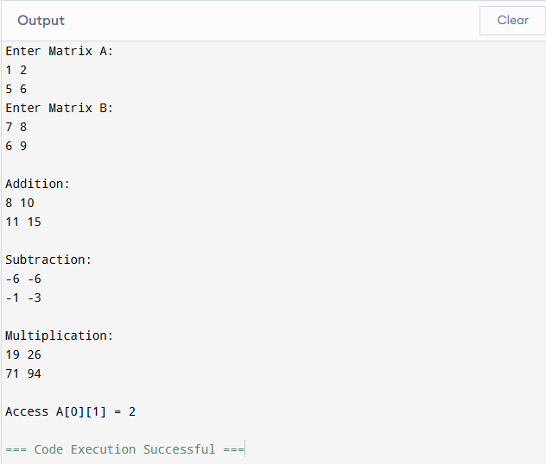

QUESTION . 02

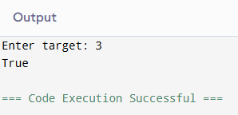

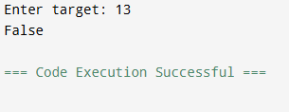

QUESTION . 03
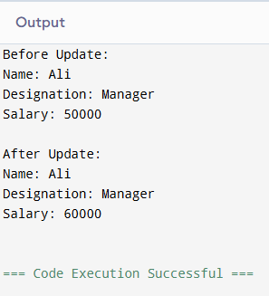

QUESTION . 04

